**Won Tok [One World] Brisbane Conference Reflection** by Fr Jon Cornish 28/02/15

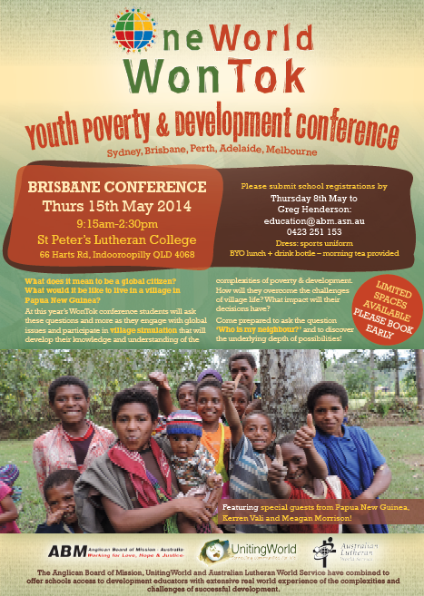

**What is Service Learning?**

Service Learning activates the **Head**, with the **Hands**, with the **Heart**. It really completes a person – having GOOD everything in sync – together as one – whole & thus Holy with God.

Service Learning is the final part – the actualisation of the heart and mind in making love visible in the world. THIS DIRECTLY RELATES TO THE GREATEST COMMANDMENT.

Jesus replied: “**'Love the Lord your God with all your heart and with all your soul and with all your mind.'** This is the first and greatest commandment. And the second is like it: **'Love your neighbour as yourself.'** All the Law and the Prophets hang on these two commandments.”

**Why is it important for students?**

Because, if they experience what grace means – through their actions, not only are they empowering the other who is marginalised – their entire view of how they can change the world for the better is also achieved.

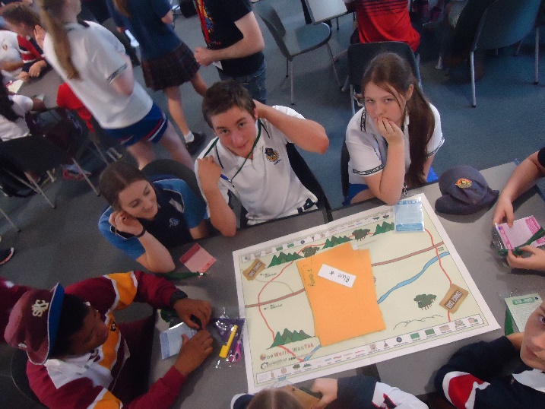

**Some thoughts on Won Tok.**

Won Tok is a form of Service Learning. It is designed to gives students a better understanding of marginalised people and communities. It tries to generate empathy, through heart based stories in conjunction with raw empirical data – along with simulated group work activities. It is a very good method of high quality learning – using modern teaching methods with a clearly developed structure for the day. It also helps teachers learn more about the situation and also it is a great exemplar teaching method.

What is Won Tok and what does it try and achieve?

