PROGRESS NOTE
Summary of Work
Since January 2016 work has been undertaken to develop a detailed understanding of ABM’s current marketing and fundraising tactics, to analyse the supporter audience and its potential for growth or decline as well as review the programs and brand of ABM to determine general marketability.
Outputs produced and provided to the Communication and Fundraising Manager have included;
- SWOT analysis
- Audit of ABM’s marketing performance in the last decade
- Stakeholder analysis
- Fundraising tactics review
- Evaluation of support base growth
- Positioning summary
- Key message analysis (draft, pending results from the survey)
Research has included interviews and meetings with key stakeholders such as communication and programs staff and the Marketing Working Group, including board members, data analysis through Raiser’s Edge fundraising database, qualitative research and analysis of current and historical marketing documentation as well as a Supporter Survey both online and in hard copy.
Key Findings
ABM has a loyal and engaged supporter base but the audience is an ageing and traditional one. The full details of ABM’s marketing strengths and weaknesses are in the attached Appendix B.
The audit of ABM’s marketing in the last decade found that standard and reliable marketing tactics have been used to communicate with ABM’s supporters which have yielded good but expected results.
To further critique current strategies, a Fundraising Tactic Review was conducted and it has been found that growth from within the existing supporter base as well as acquiring new donors from within the Anglican Church are possibilities. Segmented fundraising strategies such as those used to reengage lapsed donors or acquire new donors are under developed and resources to target new donors to grow the database are limited.
There is potential to tailor fundraising strategies to generate income growth from existing ABM supporters and opportunity to use Emergency Appeals as a donor acquisition campaign. Given the ABM donor demographic the opportunity to generate fundraising income from bequests has real potential and it is necessary to initiate new strategies in this space as soon as possible. The Communication and Fundraising team have already advanced work in this area.
The refined use of the fundraising database, although not a simple process to initiate, can assist ABM to improve targeted and tailored communication to supporters to provide more project updates based on donation history, specific to projects. This reporting and story sharing should also take the form of varied media to ensure an integrated communication approach. For example, video and social media tactics can be further developed and ABM’s traditional tactics should continue to be used.
As noted, initial research has indicated there is opportunity to grown ABM’s donor base by communicating with new audiences within the broader Anglican Church. Acquisition opportunities include clergy, theology students, nominal Anglicans and younger Anglicans.
ABM does not have detailed data regarding the age of its supporters but it is known that many of its supporters are older. To attract supporters in new audience segments, particularly those under 45 ABM could broaden its use of Social Media, use video as a story telling tool and refresh its logo and general branding to have a more modern feel.
Feedback from ABM’s top supporters in 2015 showed that 80% had a positive reaction to refreshing the brand through the use of a new logo. This is powerful feedback that suggests a brand refresh should be seriously considered.
In the research phase of this project, it was identified that certain target markets of ABM need an incentive to ensure engagement. It is also clear that ABM’s resources are well received by supporters and clergy. It is recommended that ABM’s resources be used to provide this incentive in key market segments, particularly clergy, and consequently grown ABM’s supporters.
These resources will help to reposition ABM in the minds of supporters as not only a worthwhile cause but a mission and ministry service to Anglicans. To further contribute to ABM’s repositioning, a detailed positioning summary has segmented the broader ABM audiences into niche groups who are most likely to connect with ABM’s various programs and such repositioning may offer the potential to increase fundraising income.
ABM has a complex variety of stakeholders and audiences to communicate with. As part of the review of ABM’s marketing, recommendations as to how the organisation’s different groups and committees can be used to further effectively promote ABM’s work have been offered.
Using consistent messaging in all of ABM’s marketing and promotional tools will help to encourage existing and new ABM audiences to understand ABM’s work, feel a connection to the organisation which affirms their faith and then act – whether that be to donate, pray, use resources or participate in ABM’s work in some other way. Following the results of the supporter survey, suggestions to streamline ABM’s messaging will be offered.
Recommendations Thus Far
Without pre-empting the final recommendations some findings have clear opportunities and the Board may wish to consider the following in a more immediate timeline:
- During research for the Stakeholder Analysis it was identified that a new resource that clearly but simply highlights the work of ABM or explains the complex nature of some of ABM’s work would be useful. It is recommended that an info-graphic be developed. (See example in Appendix A). This tool will simplify ABM’s complex messages but may also appeal to a younger audience. It is a simple marketing tool that could be shared electronically and as a hard copy flyer and benefit a variety of stakeholders.
- If a brand refresh is to be considered it should be noted that ABM’s annual publications go to print in the coming months and consequently it is recommended that a decision be made before or at the September board meeting, so that these will be in the new brand which will provide a consistent look for 2017.
- It is recommended that the new bequest tools that have been developed by the Communication team be rolled out to existing donors and parishes. For further growth, the bequest material could also be distributed to Anglican retirement homes and all Anglican parishes.
Next Steps
The project research has been delayed a few weeks from the initial timeline due to team workload and the mock accreditation, as well as key staff member’s leave that limited capacity to get the necessary data from the database to send out the supporter survey. However, this survey feedback is currently being sought and it is anticipated the full recommendations will be completed in July and workshopped with senior staff.
The findings and recommendations will be circulated to the board prior to the September board meeting. Following endorsement or necessary edits and feedback, a strategic marketing plan will be produced to action the recommendations.
Appendix
Appendix A- Info-graphic example
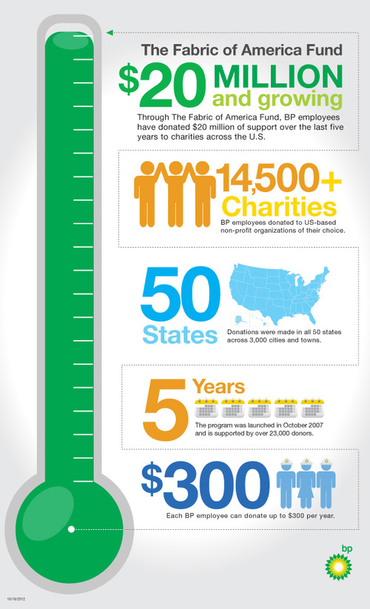
Appendix B- SWOT Analysis overleaf
SWOT
This SWOT is part of the initial research that will feed into the broader marketing project plan for ABM. The SWOT identifies the strengths and weaknesses (internal) and the opportunities and threats (external) specific to ABM’s marketing – the messages, audiences, tactics and more. Naturally, some of the points relate to ABM as a wider organisation.
The information has been collected through research and observation from the consultant as well as consultation with the communication team.
Strengths:
- Loyal and engaged supporter base
- A powerful database tool to segment audience and communicate effectively
- The official national mission agency of the Anglican Church of Australia
- Strong partnerships and relationships – both of the communication team and ABM as a whole
- Quality of work and attention to detail is high
- The missiology and ethos of ABM (the focus on partners not missionaries)is a strength-based one and the choice of ethical projects allows for positive stories to be communicated
- Appeals and publications are consistent and reliable, they are on schedule and donors know what to expect
- Resources produced are well received eg: Lent Resources
- ABM communicates effectively to the traditional ABM demographics of supporters ie: through parishes
- A trusted cause
- The variety and amount of work achieved in a small team
Weaknesses:
- A variety of messages which can compete with each other or confuse an audience– Church to Church vs Development and the number of projects
- Database under-utilised as some data is missing eg: individual donors from parishes aren’t captured or details like ages not included
- Segmented fundraising strategies such as lapsed donor or new donor strategies are under developed and resources to target new donors to grow the database are limited
- The absence of a robust bequest or “In Memory” program
- Getting current and quality information and photos from partners to assist with emotional story-telling
- The flexibility required to react to changing priorities in the organisation can create a lack of direction
- Research and Development – resources and processes don’t allow the testing or review and analysis of marketing
- Like all not-for-profits, limited resources (time, people and money) limit the amount of activities achieved in a small team. The diversity and quantity of tasks required is high
- The brand is slightly dated which can limit the appeal to a younger demographic. This is not just the logo but the logo does define the identity of the organisation and consequently, the look and feel of ABM’s collateral and promotions could be refreshed to provide rejuvenation to the brand
- Some marketing tactics have been used for long periods which can cause donor fatigue
Opportunities:
- Engaging with a young demographic through Anglican schools
- Social Media platforms can be further developed to communicate with new audiences and can also be responsive to external factors in a timely manner
- ABM securing PBI status to broaden fundraising opportunities
- Disasters and the launch of Emergency Appeals bringing new donors to ABM
- Event driven fundraising could be an opportunity to further engage a younger demographic
- Use of the wider church network to support ABM to produce more prayer resources to go with campaigns
- Partnerships with other like-minded agencies allow the sharing of resources to engage with new audiences
Threats:
- The declining demographic of ABM’s traditional supporter base
- Reduction in government funding
- Competitors including other Anglican agencies, other church based agencies as well as other charities or causes within the parish. The main other Anglican Agencies defined as competitors are – Anglican Overseas Aid, Anglican Aid (Sydney), Anglican Aid Abroad (QLD), Anglican Relief and Development Fund.
- Confusion in the marketplace – it is common that Anglicans think ABM is Anglicare
- Pull factors from the external church extend to ABM’s management and flow through to the communication team which contributes to the limited resources

