Young Anglicans Opening Worship 2016

Gathering in the Name of God

We gather in name of God: Source of all Being, Eternal Word and Holy Spirit. Amen.

Prayer of preparation
We’re here because we’re hungry
for all that God offers:
for acceptance, for challenge,
for a place and a people
who want to be with us,
who want to feast with us
whoever we are, and whatever we bring.

Give us today our daily bread,
Response: Give us today the bread of tomorrow.

We’re here because we’re hungry
for all that God offers:
for a taste of the truth –
that all is not hopeless,
that we are not helpless,
that the powers of this world
the rules of the market
will yield to God’s rule.

Give us today our daily bread,
Response: Give us today the bread of tomorrow.

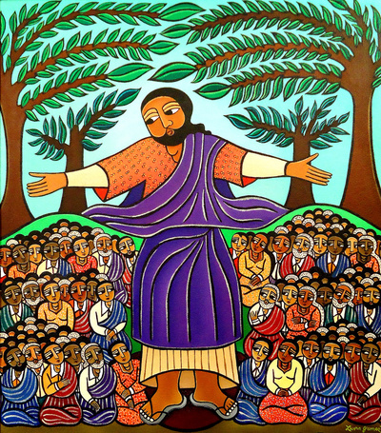
Listening to the Word of God

Scripture Readings
Isaiah 58.6-9
Luke 6:20-26

May your word live in us
and bear much fruit to your glory.

Reflection
Music – John Coleman

Praying for Church and the World

Prayers are offered, concluding with the Lord’s Prayer:
Our Father in heaven,
hallowed be your name,
your kingdom come,
your will be done,
on earth as in heaven.
Give us today our daily bread.
Forgive us our sins
as we forgive those who sin against us.
Save us from the time of trial
and deliver us from evil.
For the kingdom, the power, and the glory are yours
now and forever. Amen.

Sharing God’s Peace

We are the body of Christ,
His Spirit is with us.
The peace of the Lord be always with you.
And also with you.

We share a sign of peace with one another.

Gathering at the Table

The Lord be with you.
And also with you.
Lift up your hearts.
We lift them to the Lord.
Let us give thanks to the Lord our God.
It is right to give our thanks and praise.

With all our hearts we praise you, faithful God.
In the beginning, you called light to shine in darkness, you made living things to grow and flourish
and you created human beings in your image.
You chose us in love,
guided us by your presence
and blessed us with your holy law. Yet we chose our own sinful ways. We broke your commandments, persecuted your prophets,
forgot your wisdom
and, time after time,
refused to answer your call.
So you spoke an eternal word in a human voice in Jesus of Nazareth, son of Mary, Son of God. He called and people followed,
leaving every other loyalty.
He set us free to praise your holy name.
But hatred and violence shouted Jesus down.
Betrayed and abandoned and nailed to a cross, he laid down his life for the world he loved, and broke the chains of evil and death.
Then you turned our sorrow into joy.
On the third day you raised him up
to lead your people into life.
So we praise you, holy God, with angels and archangels and all your faithful people:

Holy, holy, holy Lord, God of power and might,
heaven and earth are full of your glory.
Hosanna in the highest.
Blessed is he who comes in the name of the Lord.
Hosanna in the highest.

On the night before he died,
Jesus gathered with his friends to share a meal and wash their feet, teaching one more lesson of love.

He took bread
and blessed you
and broke it.
He gave it to them and said: “Take this and eat it.
This is my body.”

He took a cup of wine
and blessed you
and gave it to them.
He said: “Take this and drink it. This is my blood,
sealing God’s promise to forgive your sins. Whenever you do this,
do it in memory of me.”

As we share these holy gifts, we remember the Lord Jesus.
For the love you taught us,
the sacrifice you made for us and the hope you give us, we acclaim you, O Christ:

Dying you destroyed our death.
Rising, you restored our life.
Christ Jesus, come in glory.

And now, faithful God,
send us your Spirit
to feed us with the body and the blood
of our Saviour, Jesus Christ.
Make us one body in Christ.
Send us as your messengers in the world and fill us with energy, courage and love.
Now to you, most holy God,
through Christ your Son and in the Spirit’s power, we bring our worship and our songs of praise:

Blessing and honour and glory and power
are yours forever and ever. Amen.

We break this bread to share in the body of Christ.
We who are many are one body,
For we all share in the one bread.

Going with God’s Blessing

May God bless you with discomfort at easy answers, half-truths, and superficial relationships, so that you may live deep within your heart.

May God bless you with anger, at injustice, oppression, and exploitation of people, so that you may work for justice, freedom, and peace.

May God bless you with tears to shed for those who suffer from pain, rejection, starvation, and war, so that you may reach out your hand to comfort them and turn their pain to joy.

And may God bless you with enough foolishness,
To believe that you really can make a difference in this world,
So that you can do what others claim cannot be done.
And the blessings of God Almighty, the Father, the Son and the Holy Spirit be with you now and always.
Amen.

Let us go in the peace of Christ. Amen.

Acknowledgements
This order of service is based on the order of liturgy in A Prayer Book for Australia.
Cover Art - Laura James, http://laurajamesart.com; Prayer of Preparation - Janet Morley, All Desires Known; Blessing – “Franciscan Blessing”. Thanksgiving Prayer, Sending Prayer- An Order for Holy Communion 2009, Anglican Church of Australia Liturgical Commission; Blessing – APBA.

