LAUNCHING THE ECARE WAY
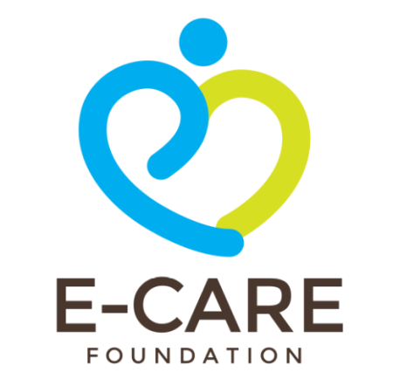

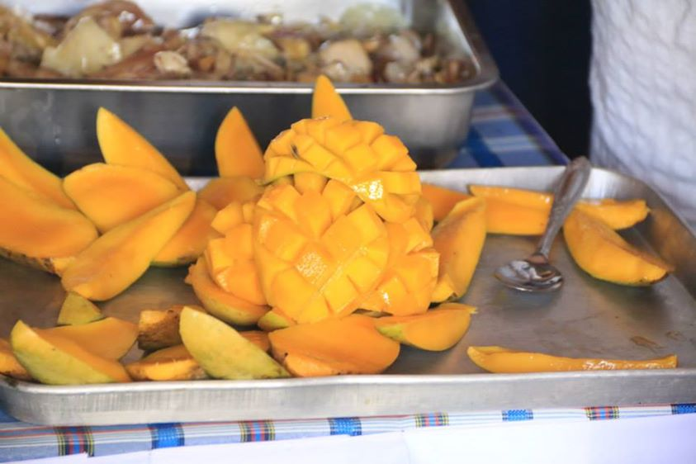
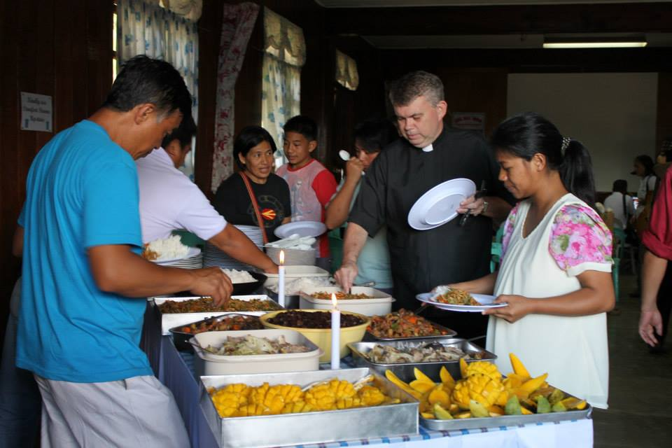
Mangoes were served at breakfast, lunch and dinner that day. These were not ordinary mangoes but were products of a natural farming method involving the use of organic conditioner, flower inducer and fruit sweetener applied on three mango trees that have not borne fruit for the past three (3) years. These trees yielded a total of 700 kgs while the neighboring trees within the same community (that did not use the method) did not bear any fruit at all. The organic mango production was applied for the first time in a partner community of the Episcopal Community Action for Renewal and Empowerment Foundation, also known as ECARE.
Figure 1. Mangoes served for lunch during the launching

It was just fitting that this first batch of organically-produced mangoes were served on the occasion of the launching of ECARE Foundation held on May 31, 2014 in Tadian, Mountain Province, since organic and natural farming is one of the main values and qualities that the said organization stands for.

ECARE is the newly-incorporated development foundation of the Episcopal Church in the Philippines, tasked to continue the mission of working with communities to enable them to mobilize their assets and resources so they can advance from a state of economic survival and/or subsistence into self-reliance and sustainability while enhancing their values of sharing, caring and witnessing. The Foundation brings into its work the learnings and insights from the ECP’s 27 years of experience in community development.

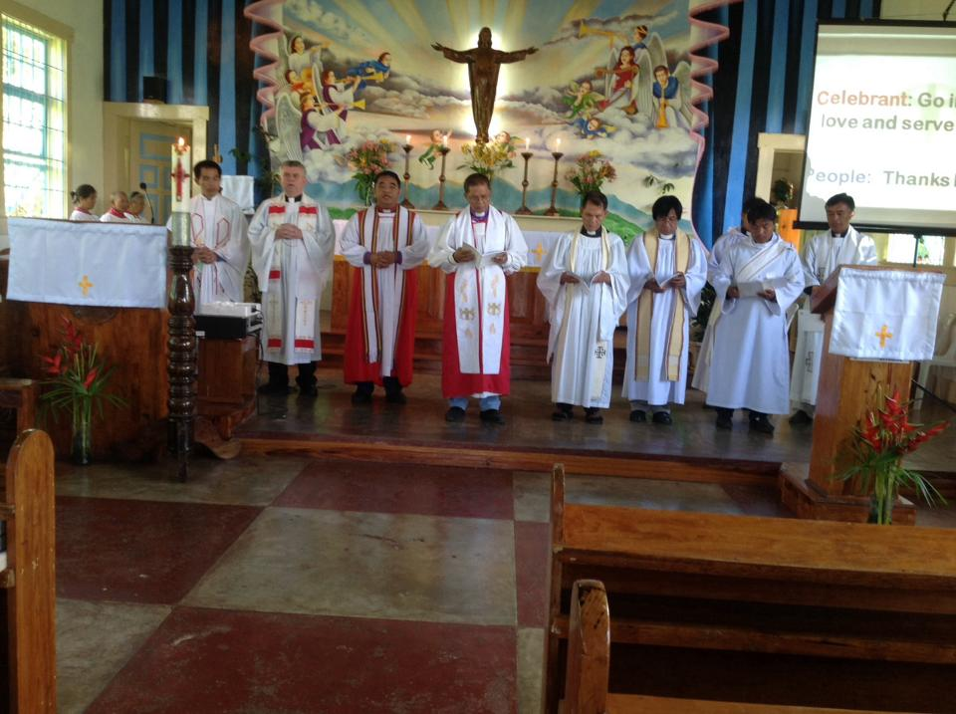
Figure 2. Holy Eucharist
The day-long launching program opened with a Holy Eucharist at St. Michael and All Angels Church in Tadian, celebrated by the Prime Bishop, The Most Rev. Edward P. Malecdan, with The Rev. John Roland Deane, Executive Director of the Anglican Board of Mission – Australia, gracing the occasion with a homily. The Bishop of the Diocese of Northern Philippines, The Rt. Rev. Brent H.W. Alawas, together with The Rev. Archimedes Turtem, Rector of the parish, and several other clergy from Tadian Deanery concelebrated in the Eucharist.

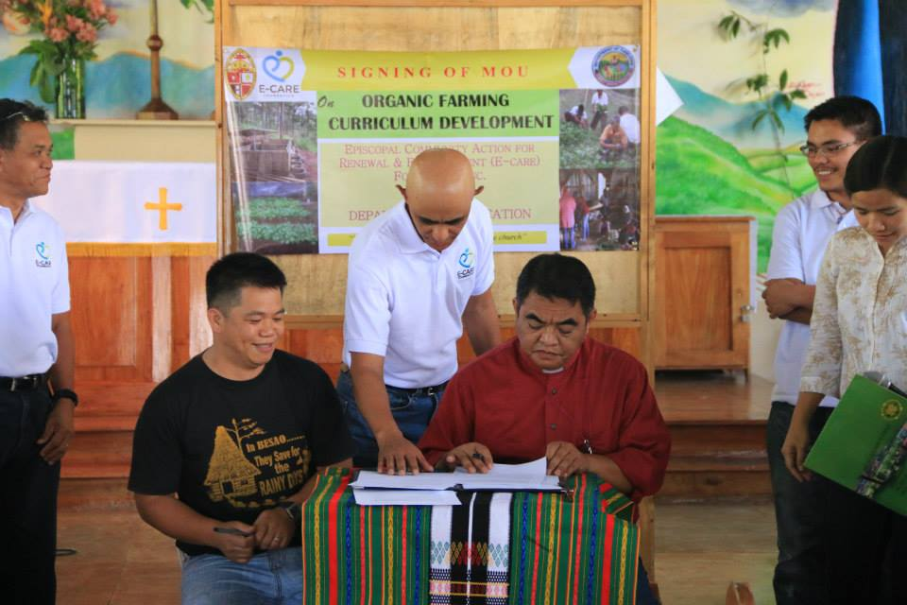
The service was followed by the signing of a memorandum of understanding between the Foundation and the Department of Education [DEP-ED] for partnership on organic agriculture promotion and curriculum development. The Mountain Province Division of DEP-ED, in line with the government’s K-12 Curriculum where the last two years of the new six-year high school curriculum will be focused on the acquisition of employable skills, has resolved to offer organic agriculture as the main track for a number of public schools in the province. It has partnered with the Foundation which has volunteered its Tadian Learning Center for Natural Farming to provide the necessary trainings to classroom facilitators, aid in development of initial and future course curriculum, provide 'on the job training' opportunities for students and provide short-courses, seminars and exposure opportunities for school field trips and potentially interested students, faculty and staff. For its part, DEP-ED will implement organic curriculum into the K-12 education system and offer the course to the senior high schools of identified public schools and promote the organic farming movement.
Figure 3. Signing of Memorandum of Understanding

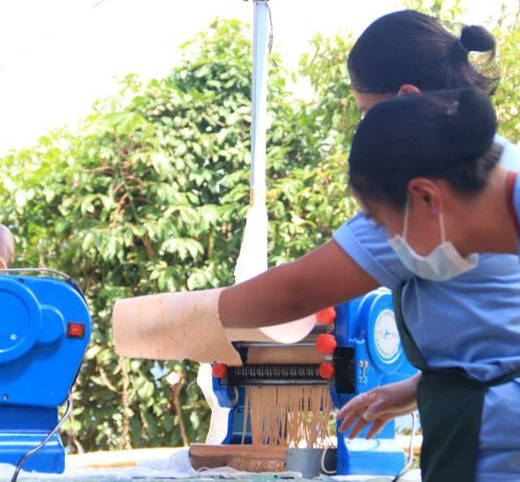
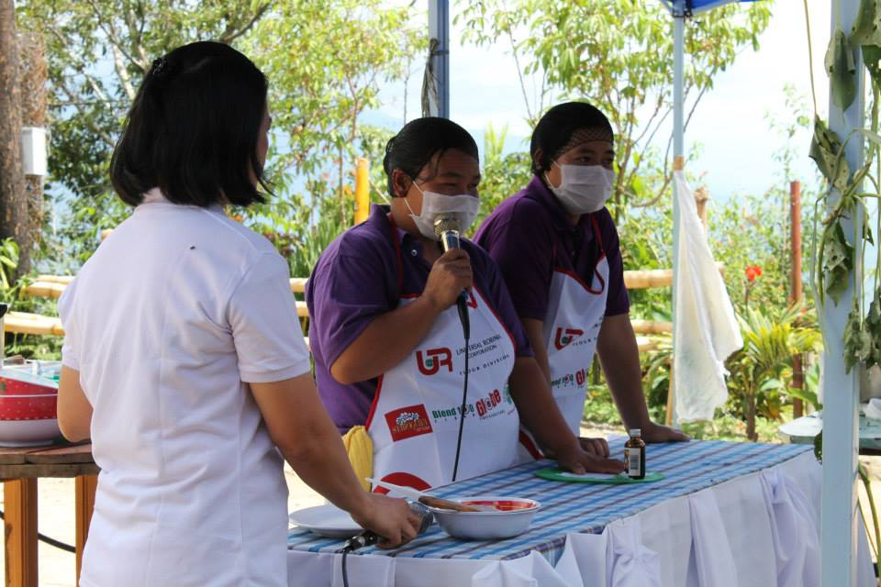
The other highlights of the launching include food preparation demonstrations and organic fertilizer and animal feeds making. Camote food preparation was demonstrated by two ladies from Ubaya Processors of Besao, Mountain Province, who, previously, were considered as the poster girls for the desperation and poverty that can be found in rural farming villages where the daily toil of farm labor does not a promise make for a better life. Today, they are the top food processors who do not only earn from the activity but have also become accredited trainors of the government’s TESDA invited to share their experiences and skills all over the province. The demonstrators for the making of vegetable noodles from Mount Data, Bauko, Mountain Province were young people who have just been out of college and have found a viable livelihood back in the farms of their village. These young people are showing that there is hope in agriculture, even for those who have taken up a college education. There was also a presentation on the preparation of what the Foundation calls Energy Mix, made up of ground rice, mongo and sesame seeds, highly recommended for infants but also nutritionally appropriate for adults. The Foundation is promoting this energy mix for the feeding program of local governments, a number of which have expressed interest and will be doing a pilot implementation in July. It was these camote products, vegetable noodles and energy mix that have been brought by the ECP as food relief to the communities in Central Philippines affected by super-storm Yolanda in the past months. Lastly, the demonstration on organic fertilizer and animal feed production received fresh and wider interest with the success of the mango production.
Figure 5. Vegetable Noodle Making
Figure 4. Camote Muffins Demo by Ubaya Processors
Figure 6. Organic Fertilizer Preparations

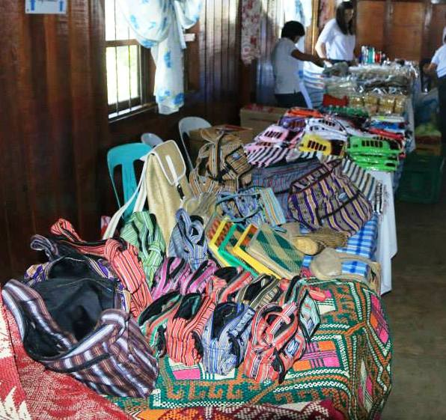
Figure 7. Products from partner communities with livelihood projects
All the activities at the ECARE launching provided a foretaste of what the Foundation seeks to undertake in what it now refers to as “The ECARE Way”. This is the embodiment of a passion for: a] the ECARE bottomlines of poverty alleviation, “receivers to givers” transformation, institutional support and congregational enhancement, b] the ECARE quality of organically grown, processed or operated, technologically appropriate, socially response and environmentally friendly, and c] the ECARE standards of conduct, covering professional and personal integrity and the never-ending quest for learning, innovation and creativity.

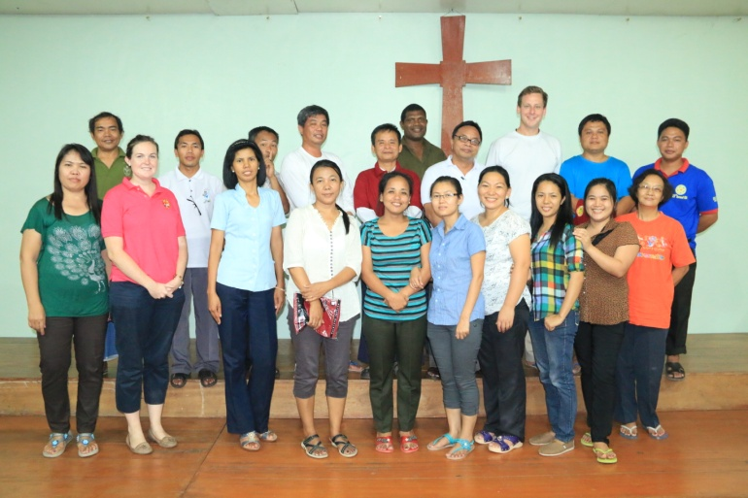
The launching was also made more meaningful by the presence and participation of eight staff persons from the Church of the Province of Myanmar and one from the Anglican Province of Papua New Guinea who are attending a six-week community development training at the Tadian Learning Center. The training is a collaboration of various partners, led by the Anglican Provinces of Myanmar and Papua New Guinea and the Anglican Board of Mission – Australia, Episcopal Relief and Development and the United Society.
Figure 8. Trainees from Myanmar and Papua New Guinea

The evening fellowship that closed the program signified that, at the end of the day, what the Foundation simply envisions is for everybody in this world to experience the blessings of friendship, sharing, caring and witnessing.

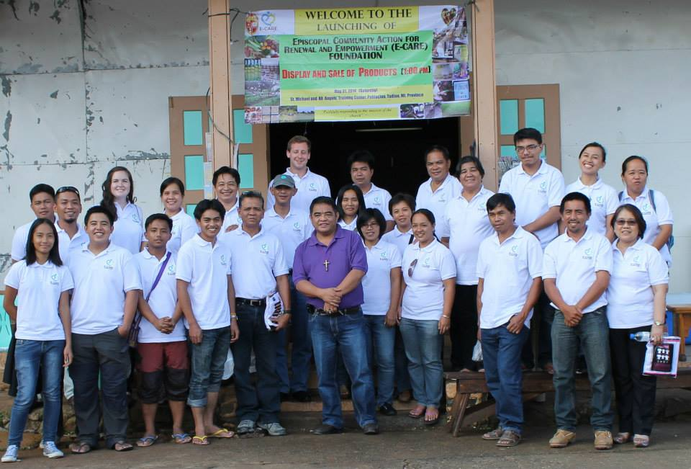
Figure 9. Episcopal CARE Foundation Staff

