1 January – 29 March 2020
Readings from
An Australian Lectionary 2020
(Year A)
Written by
Ordinands of Newton College, Papua New Guinea

In his An Exact Exposition of the Orthodox Faith (Book 4, Cap. 17, ‘Concerning Scripture’), St John Damascene ( 749) writes,

"All Scripture is inspired by God and is profitable for training in righteousness." [2 Tim. 3.16] The soul therefore gains great advantage from the reading of
the Bible.

‘ ‘Like a tree planted by streams of water,’ [Ps. 1.3] the soul is irrigated by the Bible and acquires vigour, produces tasty fruit, namely, true faith, and is beautified with a thousand green leaves, namely, actions that please God. The Bible, in fact, leads us towards pure holiness and holy actions. In it we find encouragement to all the virtues and the warning to flee from evil.

‘The Bible is a scented garden, delightful, beautiful. It enchants our ears with birdsong in a sweet, divine and spiritual harmony, it touches our heart, comforts us in sorrow, soothes us in a moment of anger, and fills us with eternal joy. Let us knock at its gate with diligence and with perseverance. Let us not be discouraged from knocking. The latch will be opened. If we have read a page of the Bible two or three times and have not understood it, let us not be tired of re-reading it and meditating on it. Let us seek in the fountain of this garden `a spring of water welling up to eternal life.' [John 4.14] We shall taste a joy that will never dry up, because the grace of the Bible garden is inexhaustible.’

We hope that these reflections will stimulate you to ponder more deeply as you read or hear what God is saying to the Church, and to you, through the Sunday and feast day readings. We hope that they inspire you to delve more deeply into the Holy Scriptures.

In Christ,

Robert McLean
Partnerships Coordinator

Ordinands from Newton Theological College, Papua New Guinea

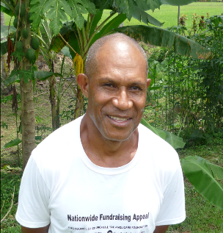
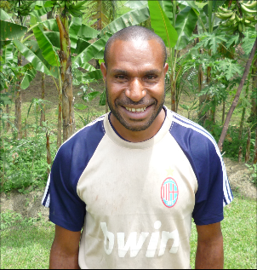
This quarter’s reflections have been written by some of the students from Newton Theological College. Newton College trains students for the ordained ministry within the Anglican Church of Papua New Guinea.
ABM supports the college with the help of generous donors from around Australia. Thank you for your support of the college through your prayers, your interest and your donations.

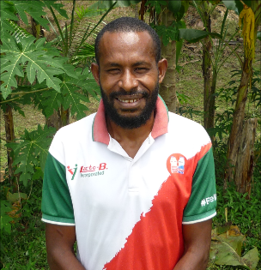
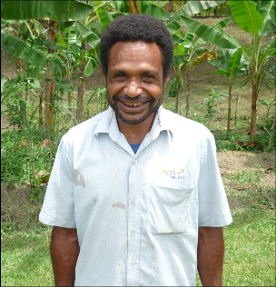

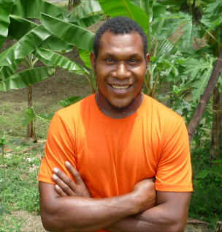
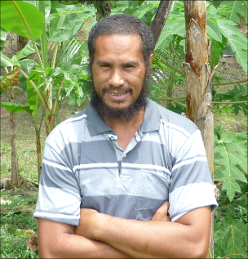

How to use ABM’s Pew Reflections
ABM’s Pew Reflections are designed for you to be able to easily cut and paste them into your pew bulletins and apply your own formatting. As every parish bulletin has its own house style it is important that you use a typeface that fits into yours but as a general guide they can be formatted like the two examples below. We try to ensure that they take up about half of an A5 sheet, though some writers are more concise than others.
Example 1
Pew Reflections
Good Friday
– Friday 3 April 2015
- Isaiah 52.13 – 53.12; Psalm 22
1 Corinthians 1.18-31 or Hebrews 10.16-25
John 18.1 – 19. 42
Good Friday could be called ‘Where is God day?’ so often is that question posed by the various texts offered today. The answer, where it is given, is in suffering, disfigurement, on a cross, where ever we would not like to look.
- Pray for the lost and the dying. Pray too for ecumenical and interfaith relationships.
- Pray for ABM’s Aboriginal and Torres Strait Islander partners, giving thanks for the work they do to further God’s mission in the world.
Text: The Very Rev. John Roundhill, Dean of Bendigo
© Anglican Board of Mission, 2015

Example 2
Pew Reflections – First Quarter 2020
Pew Reflections
Good Friday
– Friday 3 April 2015
- Isaiah 52.13 – 53.12; Psalm 22
1 Corinthians 1.18-31 or Hebrews 10.16-25
John 18.1 – 19. 42
Good Friday could be called ‘Where is God day?’ so often is that question posed by the various texts offered today. The answer, where it is given, is in suffering, disfigurement, on a cross, where ever we would not like to look.
- Pray for the lost and the dying. Pray too for ecumenical and interfaith relationships.
- Pray for ABM’s Aboriginal and Torres Strait Islander partners, giving thanks for the work they do to further God’s mission in the world.
Text: The Very Rev. John Roundhill, Dean of Bendigo
© Anglican Board of Mission, 2015

1 January – 29 March

The Naming and Circumcision of Jesus
– Wednesday 1 January 2020
Numbers 6.22-27; Psalm 8;
Galatians 4.4-7; Luke 2.15-21
The name ‘Jesus’ means ‘God saves’. God is the only one who can save us from sin and give us eternal life. Let us focus our eyes on Jesus in 2020.
- Give thanks for the work and witness of the Council of Anglican Provinces of Africa and pray for its new General Secretary, the Rev Canon Joseph William Kofi deGraft-Johnson, who begins his term today.
- Pray that many will come to accept the eternal life that Jesus comes to bring.
Text: © Anglican Board of Mission, 2020

The Second Sunday after Christmas
– Sunday 5 January 2020
Jeremiah 31.7-14 or Sirach 24.1-12; Psalm 147.12-20; Ephesians 1.3-14; John 1.10-18 or John 1.1-18
Where there is light there can be no darkness – darkness can never put it out. Let us pray that God sends light into our lives so we can be pure inside.
- Give thanks for those people like John the Baptist who point us towards Jesus, the Light of the World.
- Give thanks for the work and witness of the staff and students of Wontulp-Bi-Buya College in Cairns.
Text: © Anglican Board of Mission, 2020

The Epiphany of Our Lord
– Monday 6 January 2020
Isaiah 60.1-6; Psalm 72.1-7, 10-14;
Ephesians 3.1-12; Matthew 2.1-12
Jesus commands the apostles to go out and tell others that “The kingdom of God has come near to you.” May we find opportunities this week to do that on Christ’s behalf. Let our prayer be that we might become effective ambassadors for our Lord Jesus Christ.
- Give thanks for the revelation of God to every nation.
- Give thanks for the work and witness of the Anglican Church of Papua New Guinea, remembering especially today the staff and students at Newton Theological College in Popondetta.
Text: © Anglican Board of Mission, 2020

Ordinary Sunday 1 [The Baptism of Our Lord]
– Sunday 12 January 2020
Isaiah 42.1-9; Psalm 29;
Acts 10.34-43; Matthew 3.13-17
We see Jesus doing all that God requires of him, even though it made no sense to John the Baptist. Let us do everything that God requires of us, even if others think it is wrong.
- Pray that we will always do what God wants us to do.
- Give thanks for the work and witness of the National Aboriginal and Torres Strait Islander Anglican Council.
Text: © Anglican Board of Mission, 2020

Ordinary Sunday 2 [Epiphany 2]
– Sunday 19 January 2020
Isaiah 49.1-7; Psalm 40.1-14;
1 Corinthians 1.1-9; John 1.29-42
John points out the Lamb of God to others. Andrew comes and then brings his brother Simon to see the Lord.
- Let us pray that we can guide others to see our Lord Jesus Christ.
- Give thanks for the work and witness of the Anglican Church in Aotearoa, New Zealand and Polynesia.
Text: © Anglican Board of Mission, 2020

Ordinary Sunday 3 [Epiphany 3]
– Sunday 26 January 2020
Isaiah 9.1-4; Psalm 27.1-10;
1 Corinthians 1.10-18; Matthew 4.12-25
Jesus’ message is to turn away from our sins because the kingdom of God is near. Hearing his message and acting will help us to win eternal life.
- Give thanks for the opportunity to repent.
- Give thanks for the work and witness of the Church of the Province of Myanmar
Text: © Anglican Board of Mission, 2020

Australia Day
– Sunday 26 January 2020
Deuteronomy 8.5-14a; Psalm 125;
Hebrews 11.8-16; Matthew 5.1-12
Jesus tells us how true happiness can be found. Even if we are not called to mourn, we can work for peace or be merciful to others. In these ways we can find ourselves blessed by God.
- Give thanks that Jesus tells us how true happiness can be found.
- Give thanks for the work and witness of the Anglican Church of Australia, and the National Council of Churches in Australia. May we all be one so the world may believe.
Text: © Anglican Board of Mission, 2020

EITHER
The Presentation of Christ in the Temple
– Sunday 2 February 2020
Malachi 3.1-4; Psalm 24 or Psalm 84;
Hebrews 2.14-18; Luke 2.22-40
Simeon and Anna yearned to see the Christ, and they lived to see the fulfilment of God’s promise to send the Messiah. May we, like them, be faithful and pray patently for God to show us the good things that he is doing in the world.
- Give thanks for those who pray faithfully. Pray that you may be numbered among them
- Give thanks for the work and witness of the Episcopal Church of South Sudan. May peace soon flourish in that country.
Text: © Anglican Board of Mission, 2020

Or
Ordinary Sunday 4 [Epiphany 4]
– Sunday 2 February 2020
Micah 6.1-8; Psalm 15;
1 Corinthians 1.18-31; Matthew 5.1-12
This ‘sermon on the mount’ is a guide for all Christians. It shows us how we can be blessed by God.
- Pray that God will count you among his holy ones in everlasting glory (Song of the Church – Te Deum)
- Give thanks for the work and witness of the Episcopal Church of Jerusalem and the Middle East.
Text: © Anglican Board of Mission, 2020

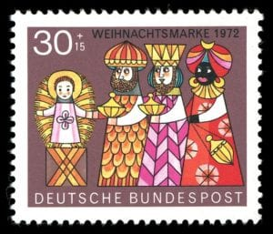
Your used and mint postage stamps
are valuable to ABM because
we can use them to help fund mission.

Please trim used stamps
with a 1 cm border around them.

Stamp collections are also gratefully received.

Please send your stamps to:
ABM
Locked Bag Q4005
Queen Victoria Building
NSW 1230

Receive regular updates from ABM
and our Partners.

Subscribe here

You can also learn about ABM on these social networking sites

Facebook
Flickr
Twitter
YouTube
Ctrl + click the icons
to follow the links

Ordinary Sunday 5 [Epiphany 5]
– Sunday 9 February 2020
Isaiah 58.1-9a (9b-12); Psalm 112;
1 Corinthians 2.1-13 (14-16); Matthew 5.13-20
Jesus calls us to be salt and light to the world. Both salt and light are good things. How can the Church be a benefit to society?
- Pray that your parish can be a blessing to the community around it. Work towards that goal.
- Give thanks for the work and witness of the Anglican Church of Kenya.
Text: © Anglican Board of Mission, 2020

Ordinary Sunday 6 [Epiphany 6]
– Sunday 16 February 2020
Deuteronomy 10.12-22 or Sirach 15.15-20;
Psalm 119.1-8; 1 Corinthians 3.1-9; Matthew 5.21-27
We read about anger, adultery, divorce and vows in today’s Gospel text. Jesus is trying to get us to behave in the right way. May we always behave as Jesus would want us to.
- Pray that you may never do anything which Jesus would be ashamed of.
- Give thanks for the work and witness of the Hong Kong Sheng Kung Hui, the Anglican Church of Hong Kong.
Text: © Anglican Board of Mission, 2020

EITHER
Ordinary Sunday 7 [Epiphany 7]
– Sunday 23 February 2020
Deuteronomy 10.12-22 or Sirach 15.15-20;
Psalm 119.1-8; 1 Corinthians 3.1-9; Matthew 5.21-27
We read about anger, adultery, divorce and vows in today’s Gospel text. Jesus is trying to get us to behave in the right way. May we always behave as Jesus would want us to.
- Pray that you may never do anything which Jesus would be ashamed of.
- Give thanks for the work and witness of the Episcopal Church in the Philippines.
Text: © Anglican Board of Mission, 2020

See over for the alternative readings
OR
The Last Sunday after the Epiphany
– Sunday 23 February 2020
Deuteronomy 10.12-22 or Sirach 15.15-20;
Psalm 119.1-8; 1 Corinthians 3.1-9; Matthew 5.21-27
We read about anger, adultery, divorce and vows in today’s Gospel text. Jesus is trying to get us to behave in the right way. May we always behave as Jesus would want us to.
- Pray that you may never do anything which Jesus would be ashamed of.
- Give thanks for the work and witness of the Episcopal Church in the Philippines.
Text: © Anglican Board of Mission, 2020

St Mathias’ Day
– Monday 24 February 2020
Acts 1.14-17, 1.20-26; Psalm 113 or Psalm 84;
Philippians 3.13-21; John 15.9-17
Jesus calls those who follow him friends. He also tells the disciples to love one another. How can we make the Church a more loving place?
- Pray that your parish shows love not only to its members but also to the community surrounding it
- Give thanks for the Church of Bangladesh, remembering especially today their ministry in a predominantly non-Christian context.
Text: © Anglican Board of Mission, 2020

Ash Wednesday
– Wednesday 26 February 2020
Joel 2.1-2, 2.12-17 or Isaiah 58.1-12; Psalm 51.1-17;
2 Corinthians 5.20b-6.10; Matthew 6.1-6 (7-16) 16-21
Jesus teaches us that if we forgive others, then God will forgive us. Let us focus on forgiveness over the next forty days.
- Let this be our prayer: Forgive us the wrongs we have done, as we forgive the wrongs that others have done to us.
- Give thanks for the work and witness of the Nippon Sei Ko Kai, the Anglican Church of Japan.
Text: © Anglican Board of Mission, 2020
The First Sunday in Lent
– Sunday 1 March 2020
Genesis 2.15-17; 3.1-7; Psalm 32;
Romans 5.12-21; Matthew 4.1-11
Jesus shows us to be careful around those whose talk is made up of biblical quotations: even Satan can quote the Bible. Be alert.
- Pray that when you read the Bible the Holy Spirit will lead you to the correct meaning.
- Give thanks for the Church of the Province of Central Africa, remembering especially the work of the Zambia Anglican Council.
Text: © Anglican Board of Mission, 2020

The Second Sunday in Lent
– Sunday 8 March 2020
Genesis 12.1-4a; Psalm 121; Romans 4.1-5, (6-12) 13-17;
John 3.1-17 or Matthew 17.1-9
Jesus tells Nicodemus he must be ‘born’ again – a birth of water and the Spirit. Our sins must be washed away and we must be alive with the Spirit’s fire.
- Pray that during Lent you will stop anything sinful and begin to become alive in the Spirit’s power.
- Give thanks for the work and witness of the Anglican Church of Korea, the Daehan Seong Gong Hoe.
Text: © Anglican Board of Mission, 2020

The Third Sunday in Lent
– Sunday 15 March 2020
Exodus 17.1-7; Psalm 95;
Romans 5.1-11; John 4.5-42
Jesus breaks all his peoples’ traditions by talking to a Samaritan woman. He uses this moment to teach that he himself is the Living Water, a spring which will provide life-giving water and give eternal life.
- Pray for all who visit and worship at the Church of Jacob’s Well, in Nablus in the Occupied Territories and for the Samaritans who live nearby, that God will bless each community.
- Give thanks for the work and witness of the Church of the Province of South East Asia.
Text: © Anglican Board of Mission, 2020

St Joseph’s Day
– Thursday 19 March 2020
2 Samuel 7.4-16; Psalm 89.19-30;
Romans 4.13-22; Matthew 1.18-25
St Joseph could have quietly let the pregnant Mary go in order to avoid a scandal, but like Mary he takes on the role that God requires him to fulfill
- Give thanks for all good fathers and step-fathers, and for all those men who seek to be better parents.
- Give thanks for the work and witness of USPG, ABM’s sister organisation in the UK and Ireland.
Text: © Anglican Board of Mission, 2020

The Forth Sunday in Lent
– Sunday 22 March 2020
1 Samuel 16.1-13; Psalm 23;
Ephesians 5.8-14; John 9.1-41
Today we learn about spiritual blindness. Let our eyes be open to spiritual things, so that, like the man born blind, we may see Jesus and follow him
- Pray for all who seek to follow their Lord. Pray too for a clear vision from God
- Give thanks for the work and witness of the Anglican Church of Melanesia.
Text: © Anglican Board of Mission, 2020

The Annunciation to the BVM
– Wednesday 25 March 2020
Isaiah 7.10-14; Psalm 40.6-13;
Hebrews 10.4-10; Luke 1.26-38
Though a scared teenager, Mary takes on the job that God has asked her to do: to be the Mother of his Son. ‘From this day for evermore, all will call her blessed.’
- Give thanks for all those who respond to the will of God with an enthusiastic Yes!.
- Give thanks for the work and witness of the Anglican Church in Aotearoa, New Zealand and Polynesia
Text: © Anglican Board of Mission, 2020
The Fifth Sunday in Lent
– Sunday 29 March 2020
Exodus 17.1-7; Psalm 95;
Romans 5.1-11; John 4.5-42
Jesus brings his friend Lazarus back to life. Jesus can make any situation, no matter how bad, immediately better. Invite him into your heart.
- Pray for all who find themselves in difficulties. Ask Jesus to knock on the door of their heart so that he may help.
- Give thanks for the work and witness of the Iglesia Filipina Independiente, the Philippine Independent Church
Text: © Anglican Board of Mission, 2020

