Climate change questions, collated from various quizzes at https://climate.nasa.gov/climate_resource_center/interactives/quizzes
1 In 2015, the level of carbon dioxide (CO2) in the atmosphere exceeded 400 parts per million. When was the last time the level of carbon dioxide (CO2) in the atmosphere exceeded 400 parts per million?  - Never in the past 400,000 years  - 325,000 years ago  - 10,000 years ago | - The 2015 Paris Agreement, ratified by most of the world’s nations, aims to limit the increase in global temperature by the end of this century to how much?  - 0 degrees increase in global temperature.  - Less than 2 degrees increase  - Less than 12 degrees increase
3 According to 2014 data, which of these 3 countries is the highest per capita producer of carbon?  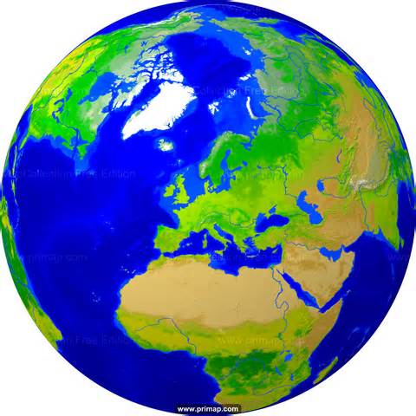  - Australia  - China  - The USA | 4 Which of these is NOT caused by increasing CO2 in the atmosphere?  - El Nino cycle in the Pacific  - Decreased soil moisture in many regions  - Stronger hurricanes
5 Other than melting glaciers and ice sheets, which of these factors has made the largest contribution to the rise in sea level over the past 100 years?  - Warming of ocean surface waters  - Melting sea ice  - Increased river run-off | 6 Which of the following would have the biggest impact on reducing carbon emissions?  - Growing our own vegetables?  - Stopping deforestation?  - Taking all fossil-fuel burning vehicles off the road?  - Shutting down all fossil fuel power plants?
7 We produce more than 30 billion tons of carbon dioxide per year. Where does the majority of it end up?  - It is inhaled by trees for photo-synthesis.  - It enters our oceans.  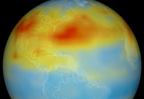  - It lingers in the atmosphere. | 8 If humans stopped emitting carbon dioxide tomorrow, what would happen to global temperatures?  - They would drop immediately.  - They would continue to rise.  - They would stop rising, flatten out, then drop.
Climate Change facts (from 2 US Government research organisations) to help answer the above questions
Ranking of the world's countries by 2014 per capita
Ranking of the world's countries by 2014 total CO2 emissions from fossil-fuel burning, cement production, and gas flaring.

1 CHINA (MAINLAND)
2 UNITED STATES OF AMERICA
3 INDIA
4 RUSSIAN FEDERATION
5 JAPAN
6 GERMANY
7 ISLAMIC REPUBLIC OF IRAN
8 SAUDI ARABIA

197 countries have ratified the 1994 UN Framework Convention on Climate Change. Most of these countries have also ratified the 2015 Paris Agreement, which aims to limit the increase in global temperature by the end of this century to less than 2 degrees Celsius.

fossil fuel CO2 emission rates, according to US Carbon
Dioxide Information Analysis Center.

1 QATAR 13.54
2 CURACAO 10.30
3 TRINIDAD AND TOBAGO 9.32
4 KUWAIT 6.93
5 UNITED ARAB EMIRATES 6.34
6 BAHRAIN 6.28
7 BRUNEI (DARUSSALAM) 5.95
8 SAINT MARTIN (DUTCH PORTION) 5.31
9 SAUDI ARABIA 5.31
10 FALKLAND ISLANDS (MALVINAS) 5.16
11 LUXEMBOURG 4.73
12 NEW CALEDONIA 4.50
13 GIBRALTAR 4.50
14 UNITED STATES OF AMERICA 4.43
15 AUSTRALIA 4.17
16 CANADA 4.12

CARBON DIOXIDE in the Earth’s atmosphere, over the past
Carbon Dioxide

We produce more than 30 billion tons of carbon dioxide per year. 40-50% of this stays in the air, while 30% is dissolved in the oceans. Scientists think the rest is probably absorbed by forests, soil and crops.

Scientists predict that increasing carbon dioxide in the atmosphere will result in more acidic oceans, decreased soil moisture in many regions, and stronger hurricanes.

To reduce carbon emissions, shutting down fossil fuel burning power stations will be more helpful than stopping deforestation.

If we stopped all carbon emissions today, global temperatures would not immediately drop. The hundreds of billions of tons of carbon dioxide that have been pumped into the atmosphere and absorbed into the oceans would continue to warm the planet.
400,000 years (according to NASA)
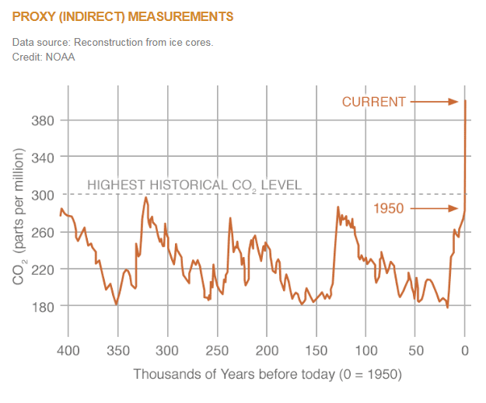
Our oceans
As the ocean warms, it expands and sea level rises, accounting for about a third of the approximately 20-centimeter sea level rise seen in the past century. Water released by melting glaciers and melting ice sheets contributes the other two-thirds of sea level rise. Melting sea ice does not contribute to sea level rise because the ice is already floating. [see https://climate.nasa.gov/quizzes/sea-level-quiz/]
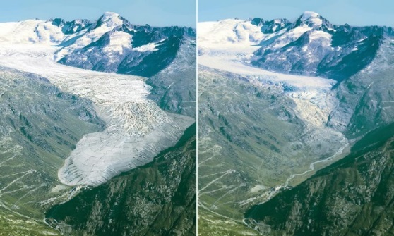
Melting glacier
Quiz Questions and answers (related to activity 2 above)
1 In 2015, the level of carbon dioxide (CO2) in the atmosphere exceeded 400 parts per million. When was the last time the level of carbon dioxide (CO2) in the atmosphere exceeded 400 parts per million?  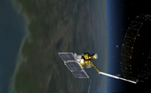  - Never in the past 400,000 years  - 325,000 years ago  - 10,000 years ago  Answer : A. Never | - The 2015 Paris Agreement, ratified by most of the world’s nations, aims to limit the increase in global temperature by the end of this century to how much?  - 0 degrees increase in global temperature.  - Less than 2 degrees increase  - Less than 12 degrees increase  Answer : B (aim is for only a 1.5-2 degrees increase)
3 According to 2014 data, which of these 3 countries is the highest per capita producer of carbon?  - The USA  - China  - Australia  Answer: C. Australia (China is the highest overall producer of carbon and the US is the 2nd highest overall producer of carbon) | 4 Which of these is NOT caused by increasing CO2 in the atmosphere?  - El Nino cycle in the Pacific  - Decreased soil moisture in many regions  - Stronger hurricanes  Answer: A. El Nino itself has been occurring for hundreds of years, though some argue that recently it has been exacerbated by climate change.

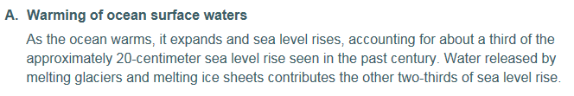
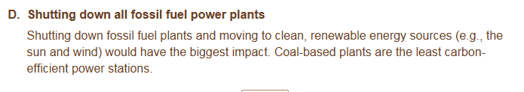
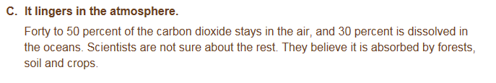
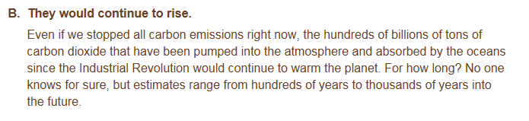

http://cdiac.ornl.gov/trends/emis/top2014.cap
https://climate.nasa.gov/vital-signs/carbon-dioxide/

